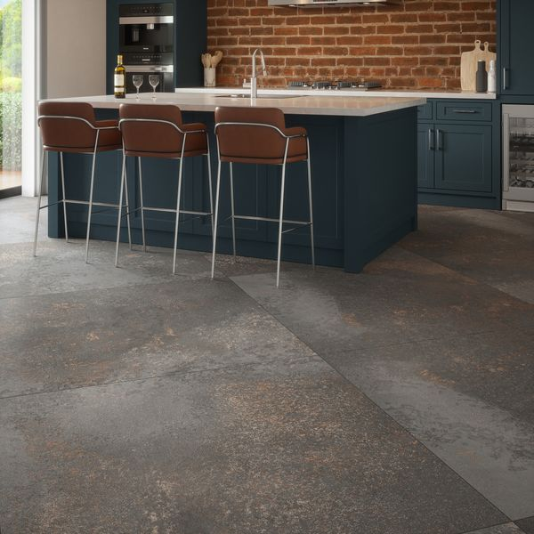**Yuri™ Graphite 90% Recycled 1175x1175 Tiles:**

## **Product Description**

Yuri™ Graphite 90% Recycled Tiles have a raw, industrial feel that emanates the look of salvaged metals and concrete, with small details in their appearance like abrasions and oxidisation. Reminiscent of British cliffs moulded by rain and sea, varied shades of carbon grey collide together with metallic rust-browns to create a mottled look, alive with character and charm. Made from 90% recycled raw materials, water and minerals, with an eco-friendly manufacturing process and no compromise on quality and finish, these tiles are highly variegated, with multiple faces for a unique look. Available in two sizes, these tiles feature an R10 anti-slip surface, also PTV +36, so they are suitable for any area of your home.

**What’s special about these tiles?**

> Made from 90% recycled materials

> Infinite variations for a unique look

> Rectified edges for a sleek, seamless look

> R10 anti-slip surface and

> Subtle matt finish

## **Product INFO**

* Product ID: 45013
* Tiles Per SQM: 0.72430964237211
* Sale by: Per SQM
* Size: 1175x1175x11mm
* Weight: 48.08 KG
* Material Type: Porcelain
* Finish: Matt
* Colour: Grey
* Suitability: Floors, Walls
* Area Of Usage: Internal, External
* Grade: 4
* Rectified Edge: Yes
* Underfloor Heating: Yes
* Anti Slip Grade: R10 / 19-27 Degrees
* Thickness (mm): 11